**Spike:** 16

**Title:** Soldier on Patrol

**Author:** Ben Holmes, 103024841

**Goals / deliverables:**

Create a “soldier on patrol” simulation where an agent has two or more high-level FSM modes of behaviour and low-

level FSM behaviour. The model must show (minimum)

(a) High level "patrol" and "attack" modes

(b) The "patrol" mode must use a FSM to control low-level states so that the agent will visit (seek/arrive?) a

number of patrol-path way points.

(c) The "attack" mode must use a FSM to control low-level fighting states. (Think “shooting”, “reloading” - the

actual states and transition rules are up to you.)

**Technologies, Tools, and Resources used:**

* Visual Studio Code
* Python 3.12.2
* Pyglet

**Tasks undertaken:**



* Copied code from spike 15
* Adjusted the patrol path code I developed in task 15 to use an agent specific set of 4 points roughly in top left, top right, bottom left and bottom right.

* Adjusted patrol mode code to change mode to attack if a target agent exists

* Created an attack mode that shoots if there are enough bullets (with a delay between shots) and triggers a reload function if not. It also seeks to the target_agent position. If the target agent does not exist then it switches back to patrol mode

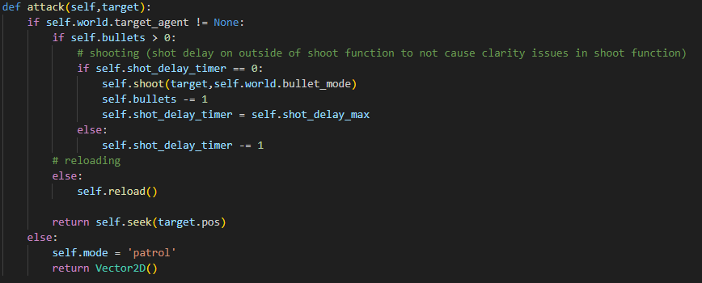

* Created the reload function and the time/state variables for the bullets, reloading and shot delay

* Bullet class in bullet.py is unchanged from task 15
* Adjusted how the bullet registered hits and how that interacted with the target agent, mainly changing to use target_agent = none and target agent != none

* Adjusted the spacebar to create a new target_agent if one didn’t exist in wander mode for a bit more interactiveness

**What we found out:**

As I had already implemented a patrol mode in task 15, it was simple to adjust it to be at the agent level instead of the world level. I had also created the shoot function to be very modular, so it was simple to just move that to within the attack function and use the attack mode instead. The only slight difficulty was getting the removal of the target agent when hit to work because of how the bullet hit check works.

Because of task 15 various mechanics like the bullet speeds and inaccuracies are still implemented in this one, having been tested and encountering no issues

**Testing buttons:**

Spacebar creates a target agent if one exists

Bullet modes numpad:

1: rifle (fast accurate)

2: rocket (fast inaccurate)

3: pistol (slow accurate)

4: grenade (slow inaccurate)